To describe the figures

Figure 1

Time series showing the monthly change of BARRA-TA and six CCAM models from 2007 to 2016.

Figure 2

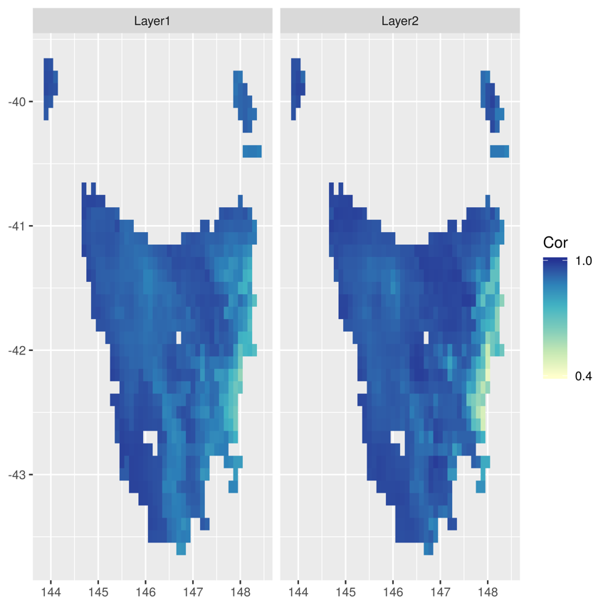

Map showing the correlation of soil moisture at layer 1 and 2 between CCAM ensemble and BARRA-TA.

Figure 3

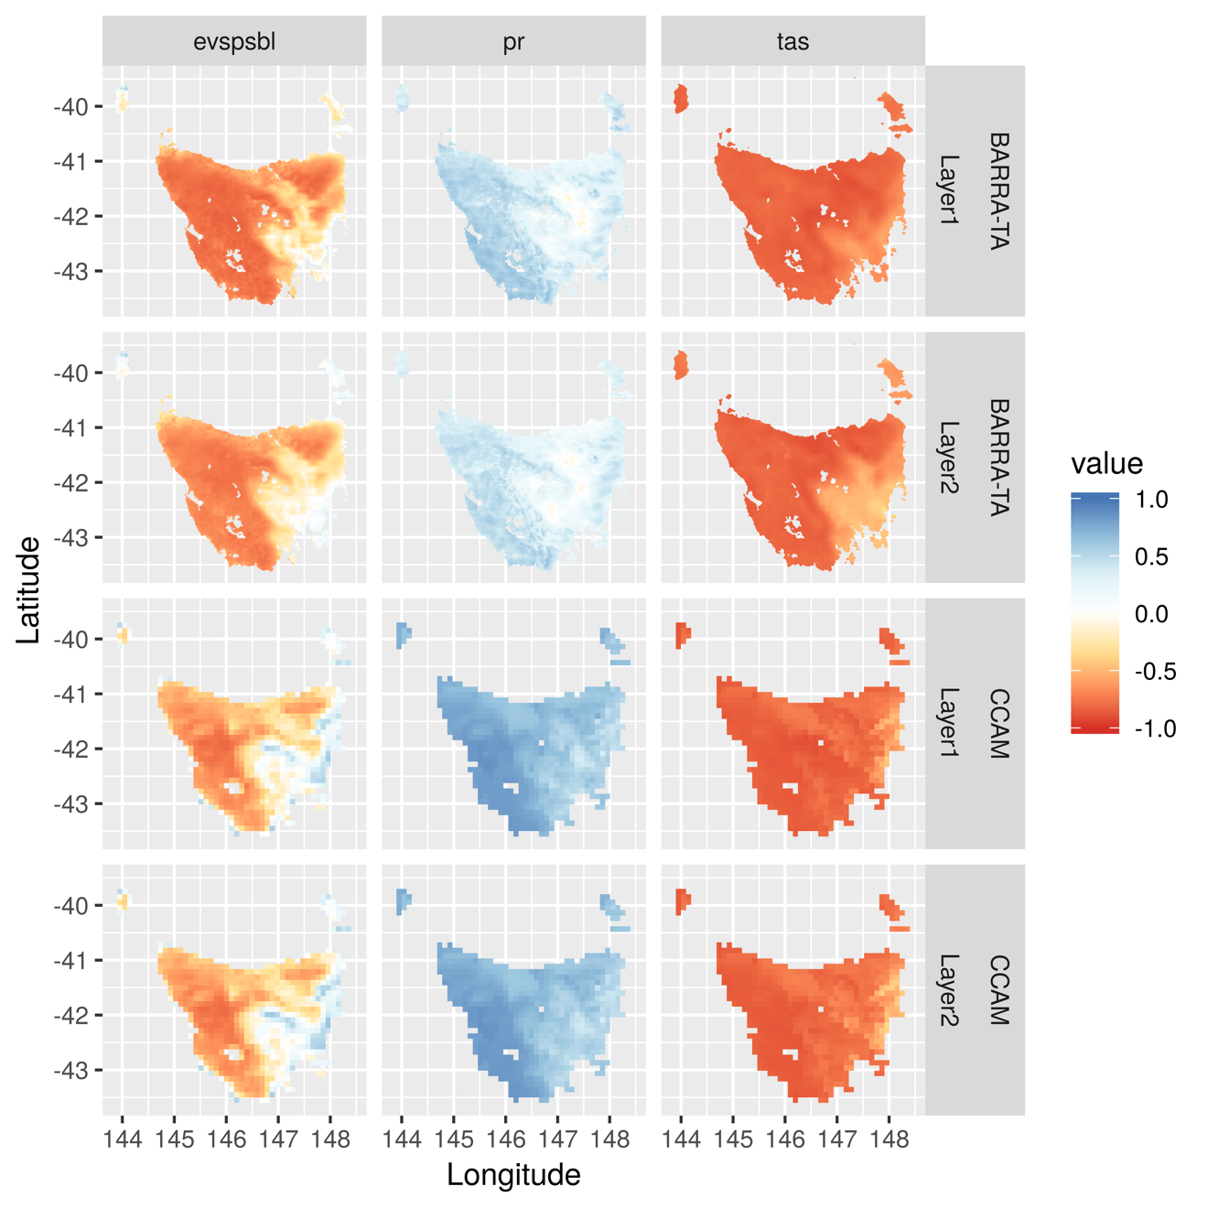

Maps shows the correlation between soil moisture at layer 1 and layer 2 and the three relative variables by each CCAM ensemble and BARRA-TA.

Figure 4

Maps show the percentage of seasonal change of soil moisture at layer 1 and 2. The start and end values are the mean value of each 30 years.

Figure 5

Maps showing the percentage of seasonal change of evaporation and precipitation from 1960-1989 to 2070-2099. The start and end values are the mean value of each 30 years.

Figure 6

Time series showing the multi-year monthly mean values from three periods by the four variables at area A.

Figure 7

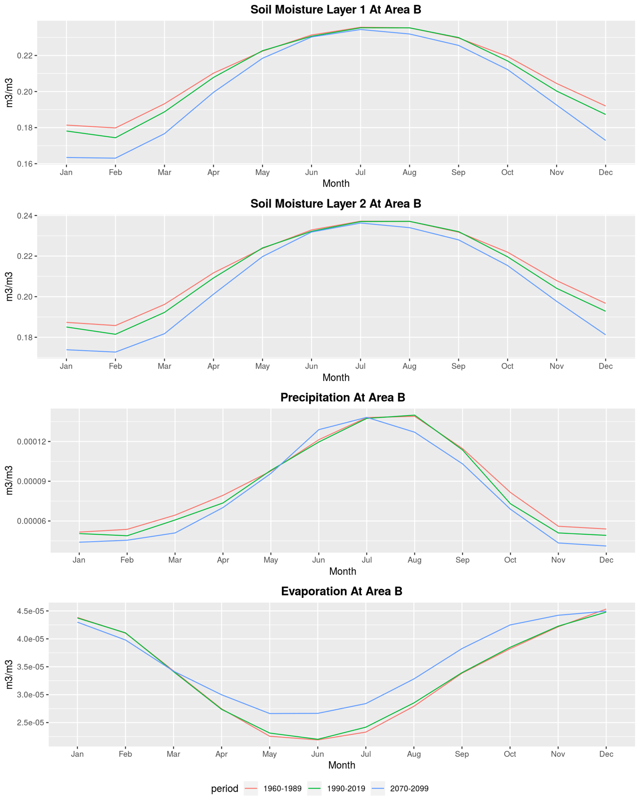

Time series showing the multi-year monthly mean values from three periods by the four variables at area A.

Figure 8

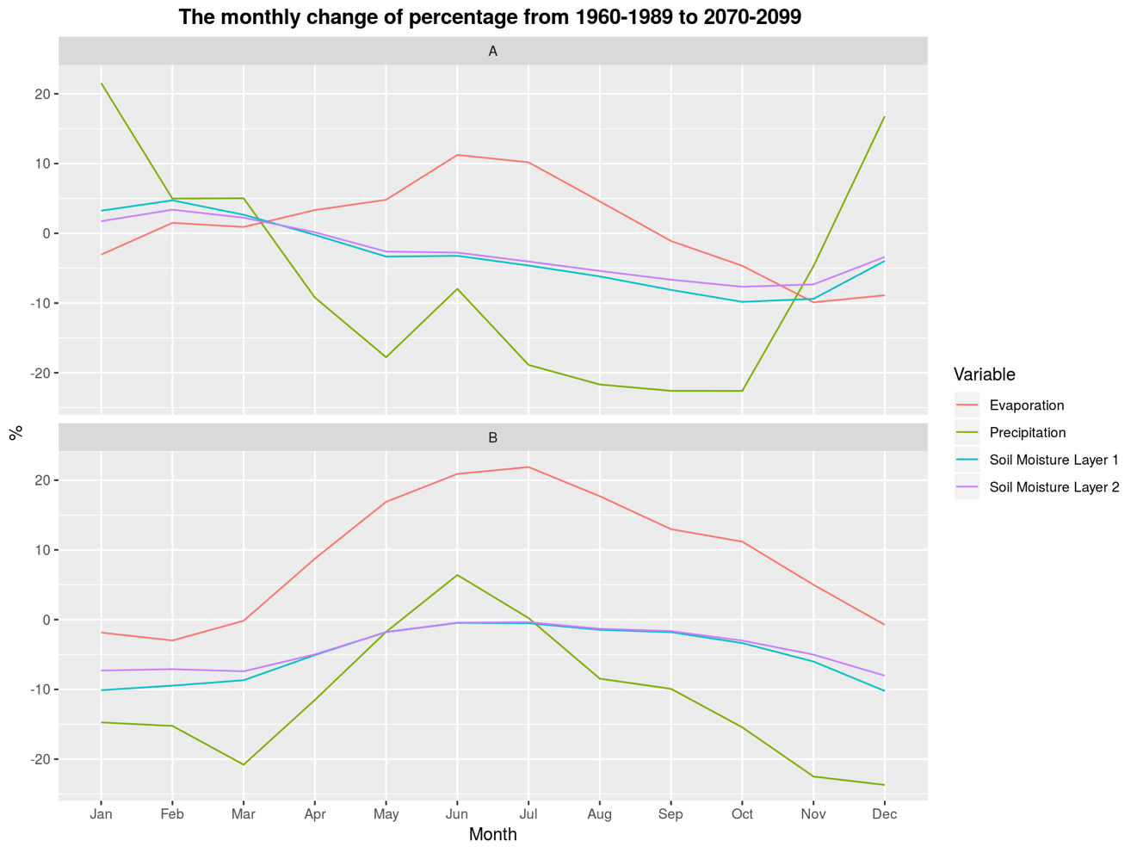

Time series showing the percentage of the change of the multi-year monthly mean values from three periods by the four variables at area A and B.

Table 1

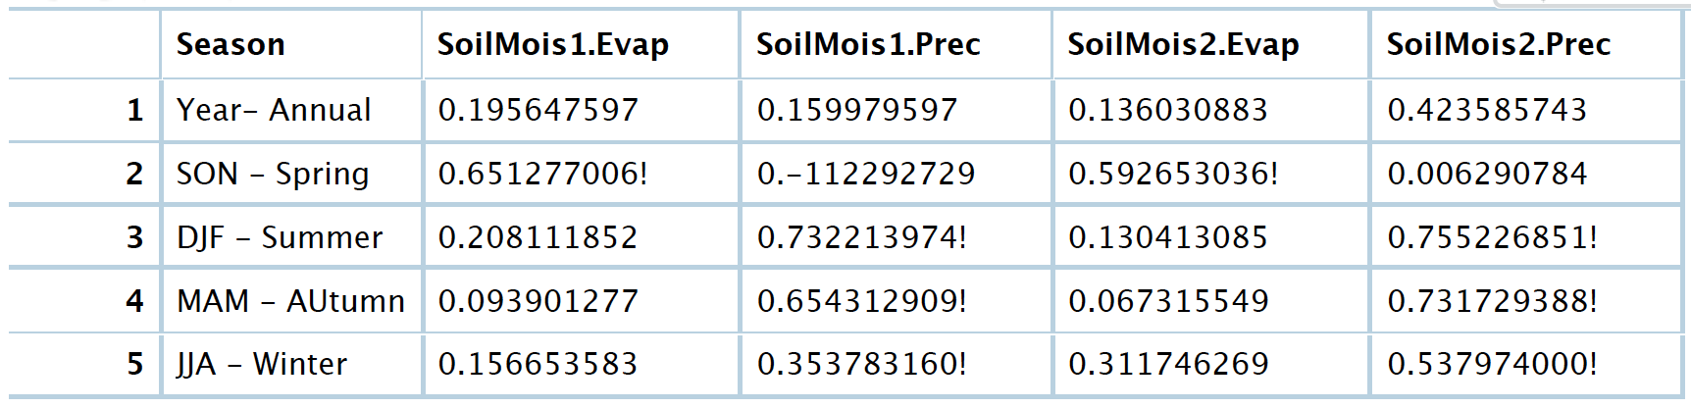

Table showing the spatial correlation between soil moisture at layer 1 and layer and the two relative variables.